Create an AWS Org. for managing multiple accounts , grouping , budgeting and centralized way to handle all the things

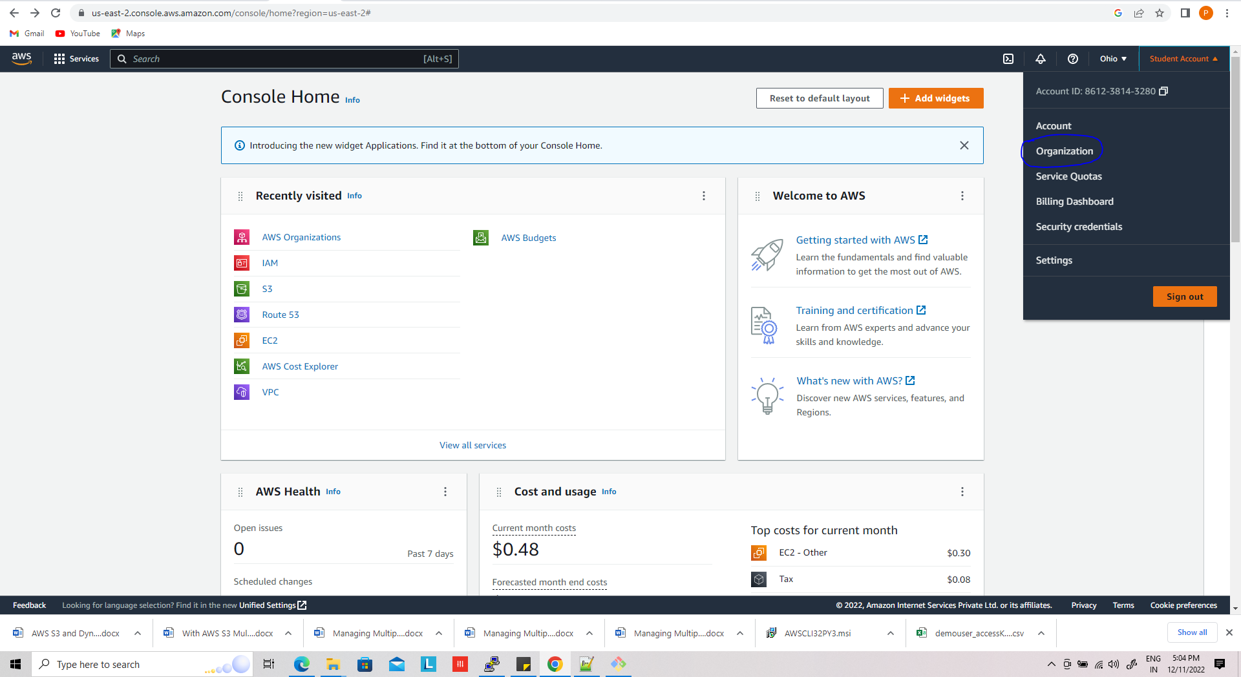

Click on drop down and choose organization

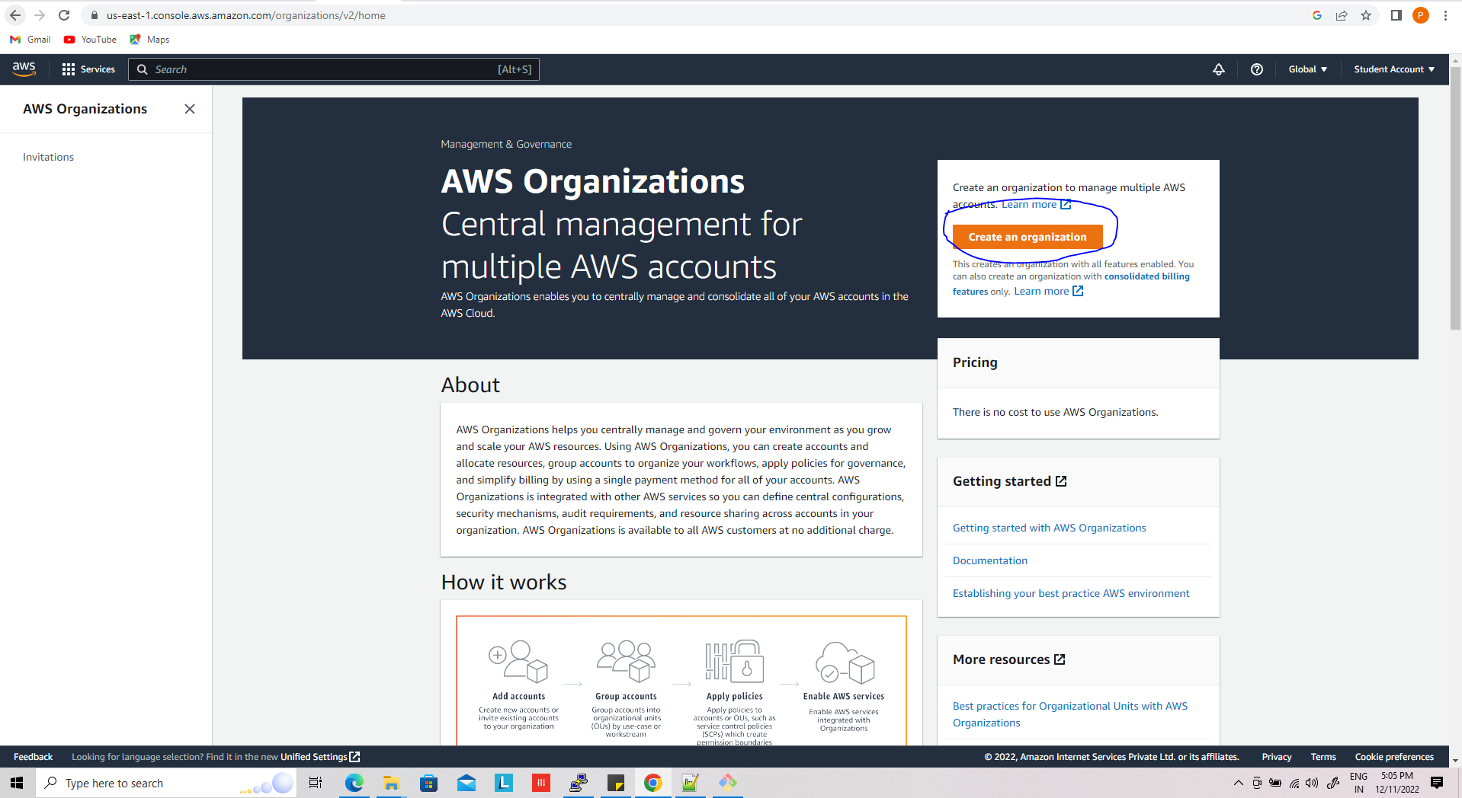

Once org has been created you see,

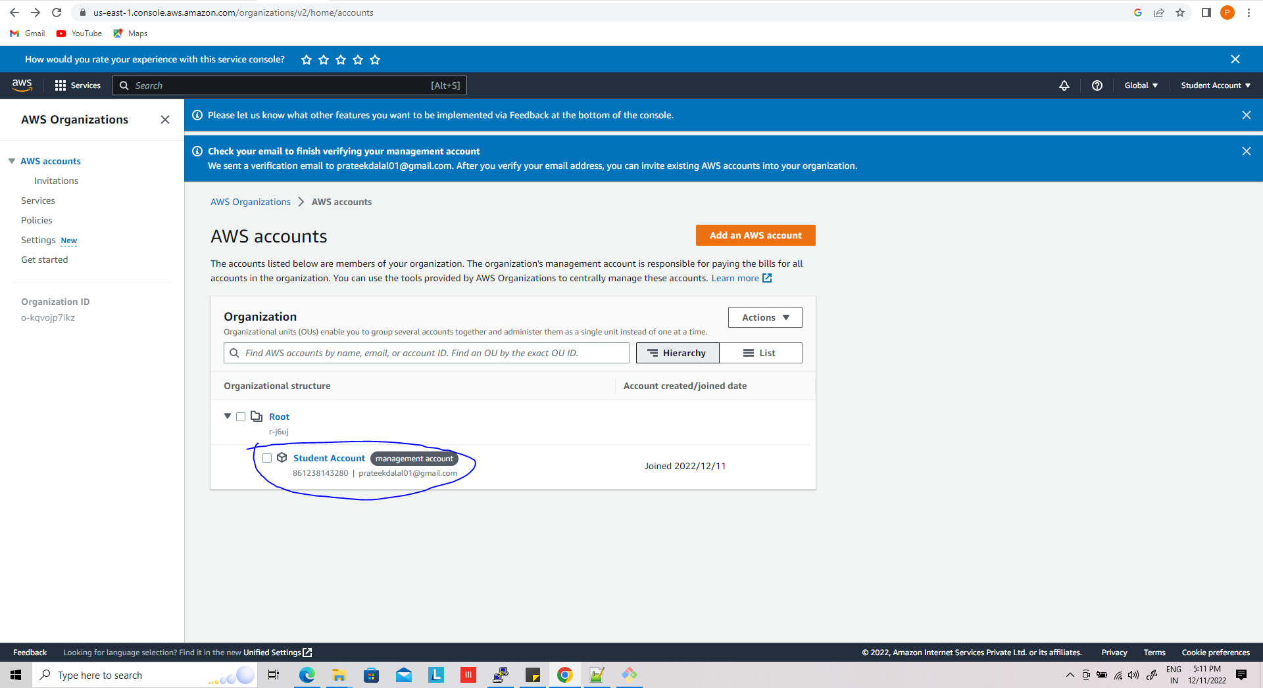

Now add new account just clicking on add aws account

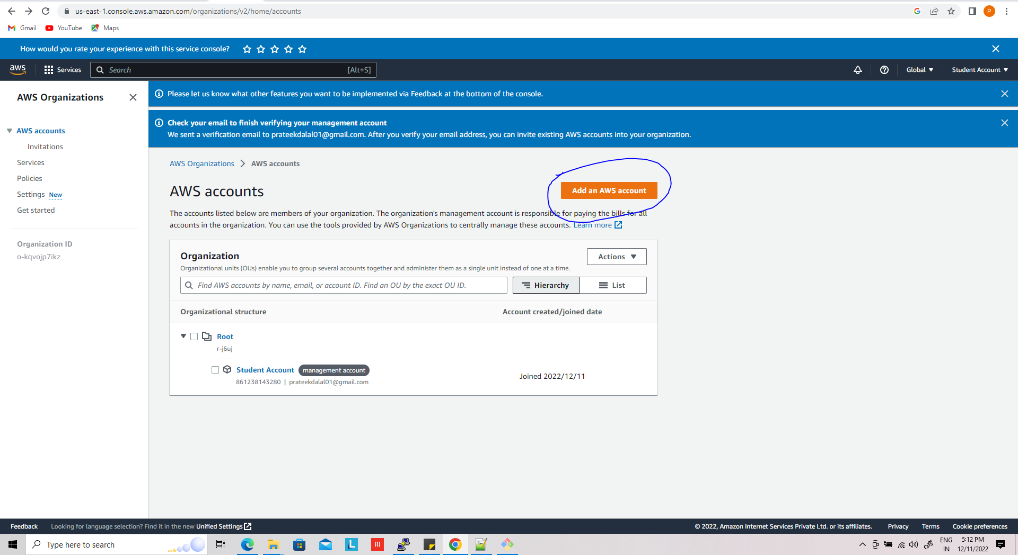

You can see two option , create new and add existing aws account,

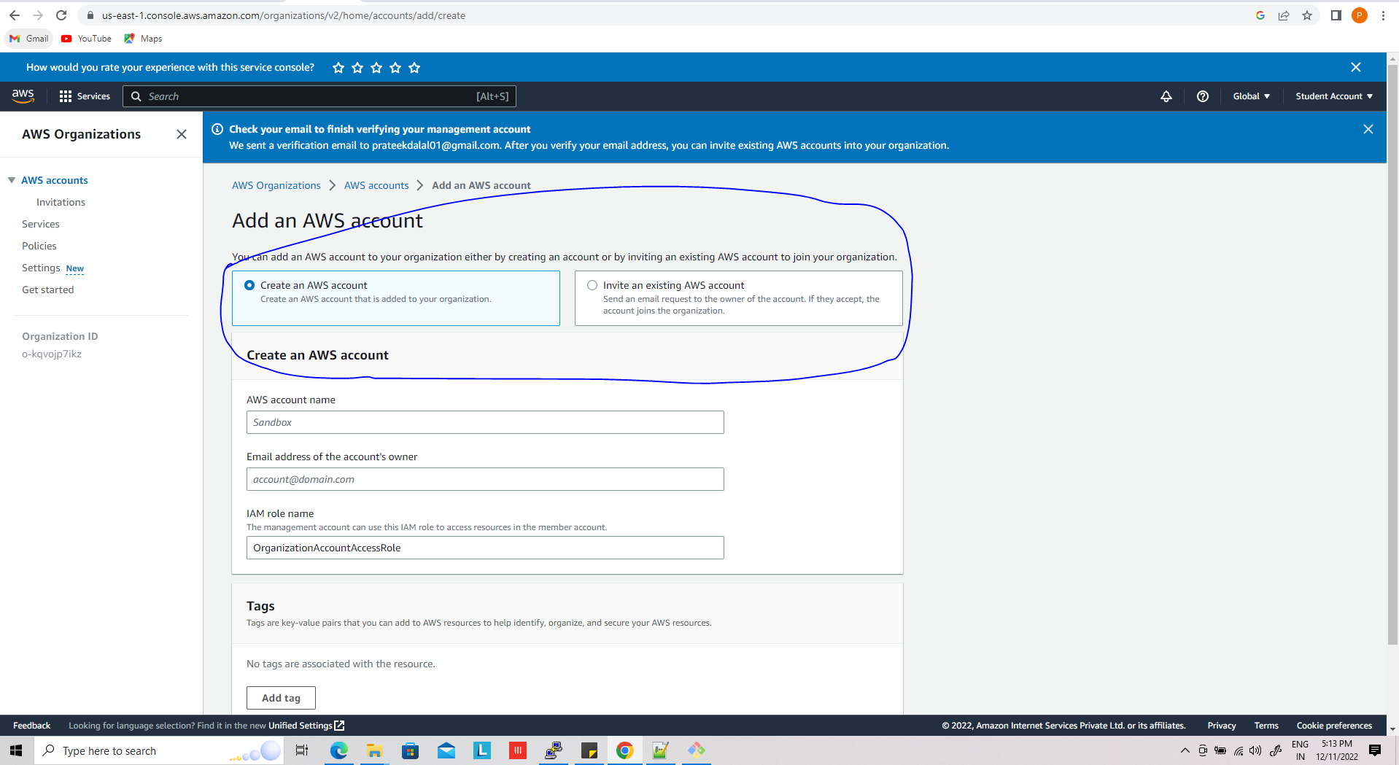

When you choose adding existing account you get following option,

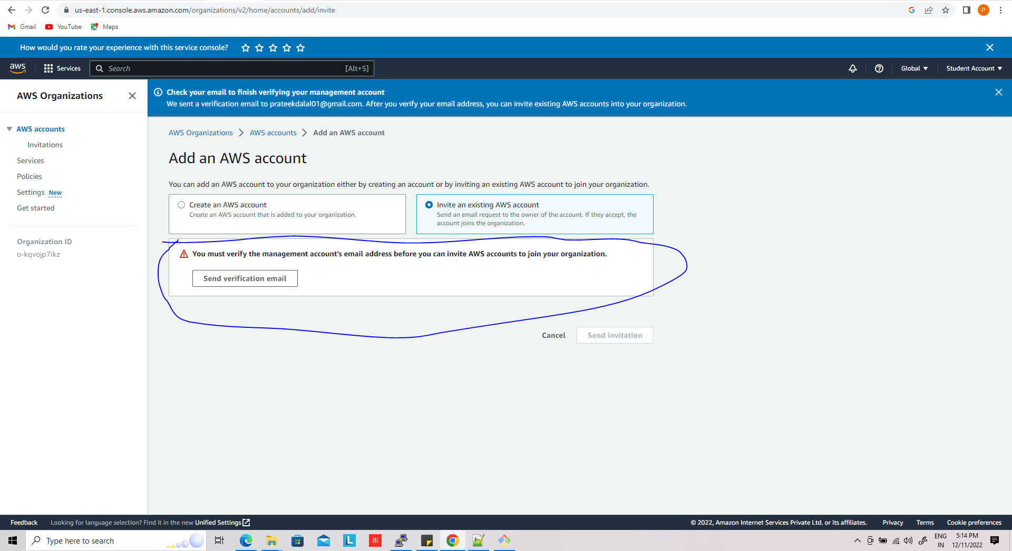

This will send invitation to your email id just accept and be a part of this aws org.

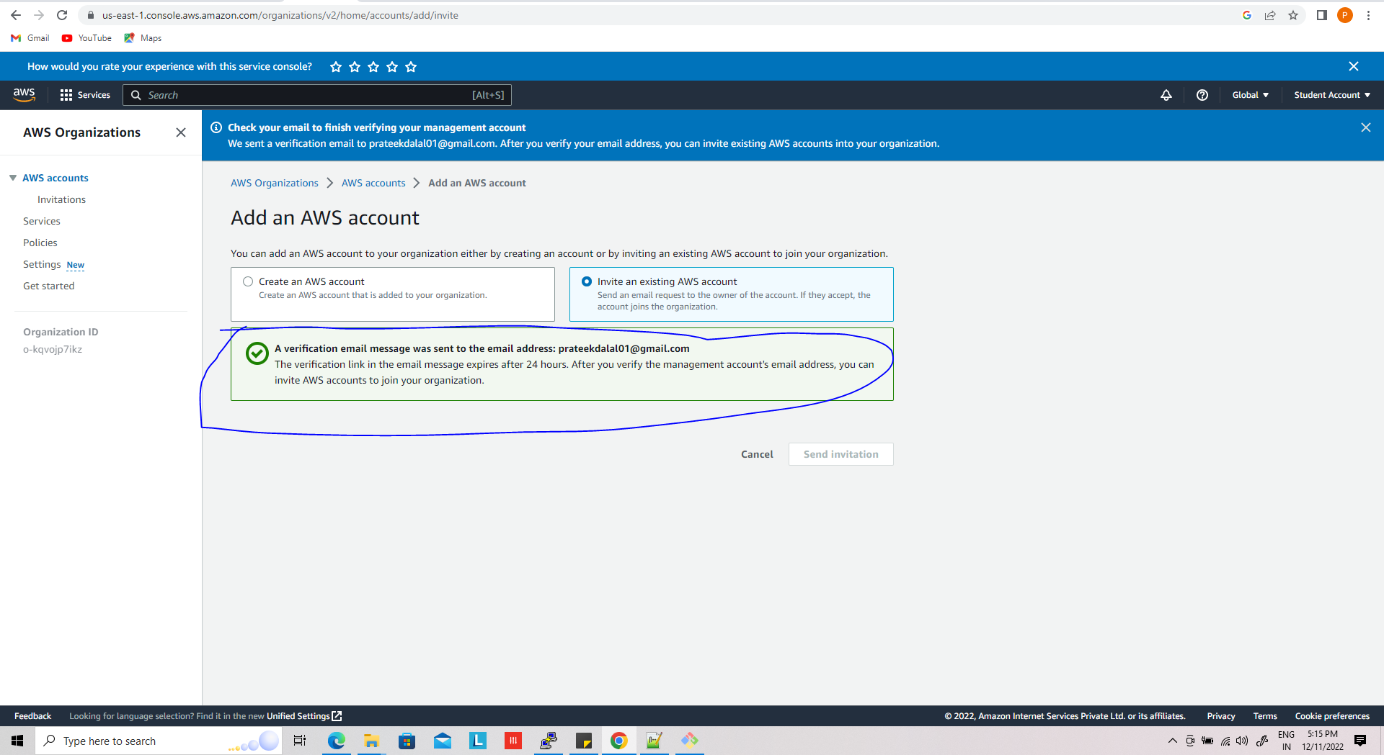

You can see in the gmail,

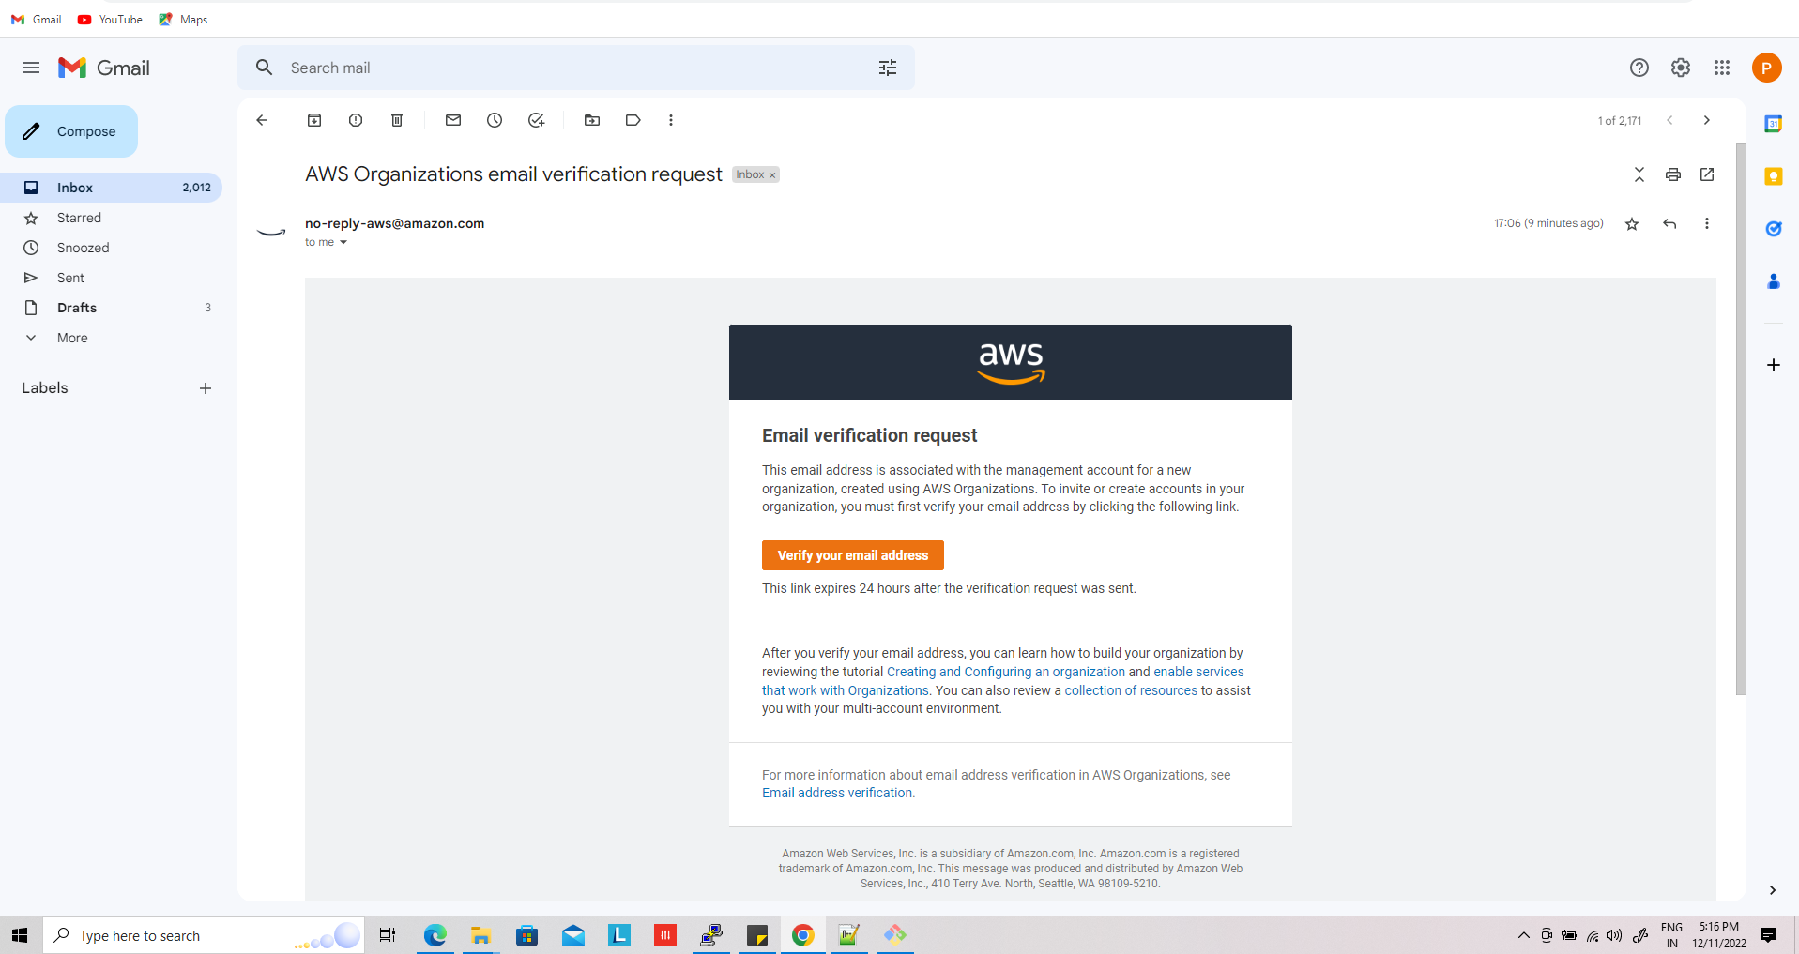

Once verification has been done you see like this

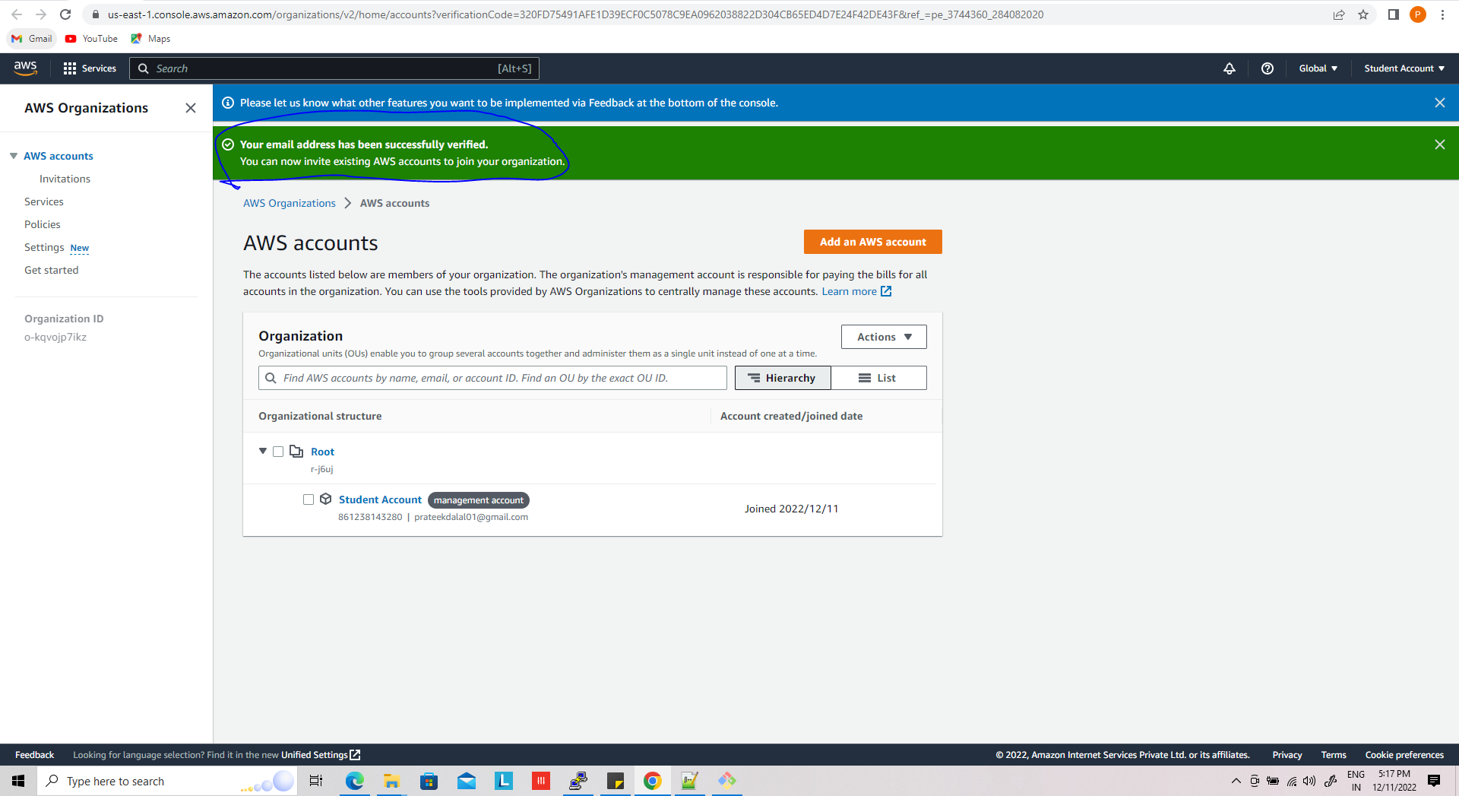

After verification , you can add as many as services to the account,

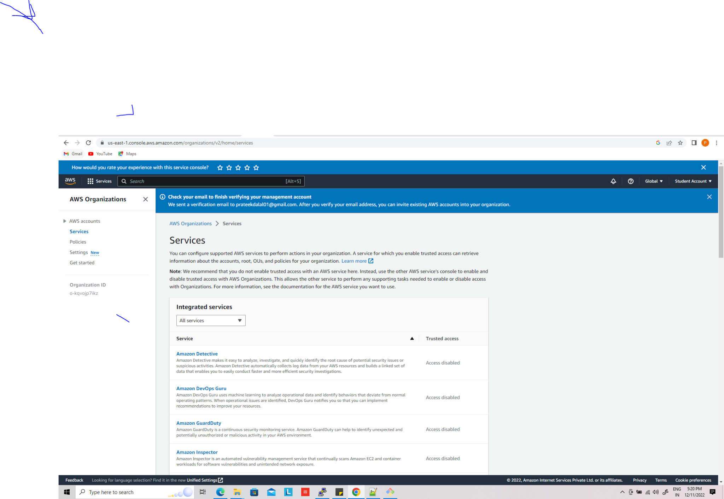

Now you can choose policies , and enable as per your need

